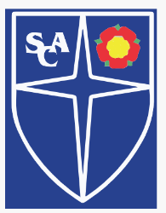
ST.ANNE’S COPP CHURCH OF ENGLAND PRIMARY SCHOOL, GREAT ECCLESTON

PERSONAL, SOCIAL AND HEALTH EDUCATION POLICY
(including Relationships and Sex Education)

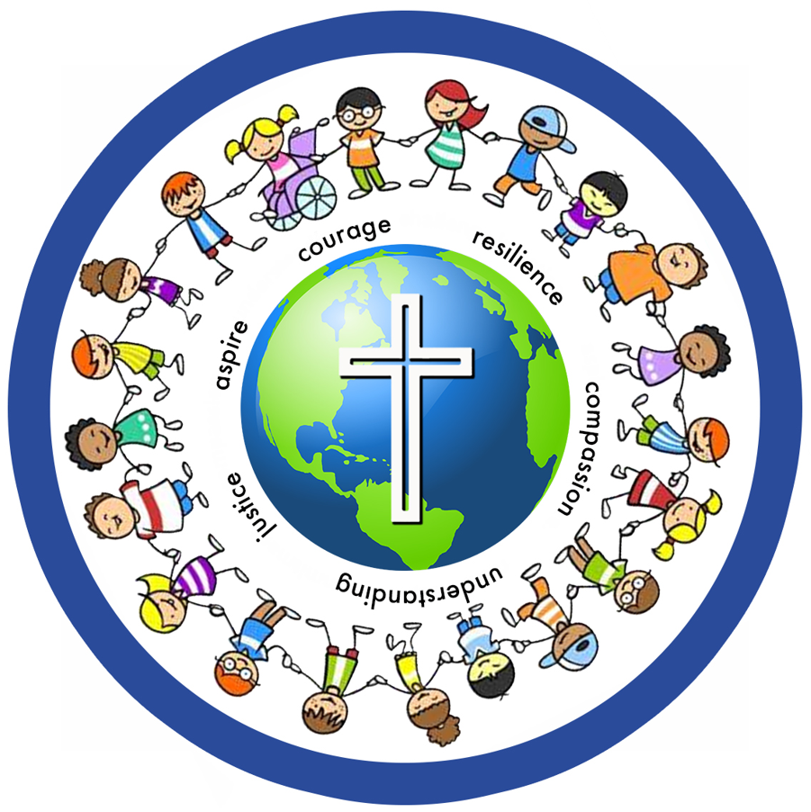

“Let us love, not in word, but in truth and action.” (1 John 3:18)

June 2026

Approved by GB: June 2026
Next review due: June 2027

In building solid foundations for every unique individual and putting God’s love at the centre of all we do, our children learn to embrace our diverse world. We encourage our children to learn universally in order to understand our heritage and roots as a village, town, region and nation. Through strong community links, our children grow in compassion and understanding, promote justice and possess commitment and aspire to make a positive difference. We offer an ambitious curriculum that ignites curiosity along with high personal expectations that fosters resilience and which enables them to flourish. Our children are easily distinguished by the courage they show when making brave choices and understand the importance of becoming the very best versions of themselves.

DEFINITIONS
- Relationships Education is the programme of work that forms part of the basic curriculum. It focuses on teaching the fundamental building blocks and characteristics of positive relationships including; families, caring friendships, respectful relationships, online relationships, being safe and respect for others.
- Sex Education is a programme of work that covers romantic relationships, conception and consent, linking to our Science Curriculum (which covers human reproduction). It does not promote sexual activity.
- Health Education is a programme of teaching about puberty, physical health and fitness, healthy eating, mental wellbeing, drugs, alcohol and tobacco.

WHY WE TEACH RELATIONSHIPS AND SEX EDUCATION:
At St Anne’s Copp Church of England Primary School, we believe that all children should have a clear understanding of the changes that will happen to them throughout their time at school. We aim to equip them with the appropriate age-related knowledge to support them in making their own correct informed decisions. Our school’s approach to Relationship and Sex Education (RSE) goes beyond the provision of biological information and is more than the school’s previous approach for Year 6.

Our aims are:
- To prepare children for healthy relationships in an online world
- To prepare all our pupils for the challenges of adult life
- Enable our pupils to make informed healthy life choices
- Nurture the self-esteem and emotional development of all our young people
- Provide a framework in which sensitive discussions can take place
- Prepare pupils for puberty, and give them an understanding of sexual development and the importance of health and hygiene
- To enable pupils to understand the qualities of healthy relationships based on Christian principles, including the importance of marriage and lifelong commitments
- To ensure RSE is part of a child’s broad, balanced curriculum, integral to the basic curriculum of the school and part of the child’s all-round development
- To understand how to stay safe, know the importance of boundaries and how to report abuse or feelings of being unsafe
- Help pupils develop a positive and secure personal identity, a sense of their own value and feelings of confidence and empathy
- Teach pupils the correct vocabulary to describe themselves and their bodies
- Create a positive culture around issues of sexuality and relationship
- To ensure that all understand the importance of respecting others and accepting those who differ
- To know how to ‘love your neighbour’ even when we might disagree.

The teaching of RSE contributes to spiritual, moral, social and cultural development. The spiritual development of pupils is shown by their:
- ability to be reflective about their own beliefs and values, religious or otherwise, that inform their perspective on life and their interest in and respect for different people’s faiths, feelings and values
- sense of enjoyment and fascination in learning about themselves, others and the world around them
- use of imagination and creativity in their learning
- willingness to reflect on their experiences.

The moral development of pupils is shown by their:
- ability to recognise the difference between right and wrong and to readily apply this understanding in their own lives, recognise legal boundaries and, in so doing, respect the civil and criminal law of England
- understanding of the consequences of their behaviour and actions
- interest in investigating and offering reasoned views about moral and ethical issues and ability to understand and appreciate the viewpoints of others on these issues.

The social development of pupils is shown by their:
- use of a range of social skills in different contexts, for example working and socialising with other pupils, including those whose views differ from their own
- willingness to participate in a variety of communities and social settings, cooperating well with others and being able to resolve conflicts effectively.

STATUTORY GUIDANCE
As a maintained primary school, we must provide relationships education to all pupils under section 34 of the Children and Social Work Act 2017. We are not required to provide sex education, however, we have worked closely with our feeder high schools and know our pupils well in order to determine that we need to begin to build up their knowledge of sex education in the summer term of Year 6. School also teaches the elements of sex education contained in the science curriculum which is compulsory.
In teaching RSE, we must have regard to guidance issued by the secretary of state, as outlined in section 403 of the Education Act 1996.
We must also have regard to our legal duties set out in:
- Sections 406 and 407 of the Education Act 1996
- Part 6, chapter 1 of the Equality Act 2010
- The Public Sector Equality Duty (as set out in section 149 of the Equality Act 2010). This duty requires public bodies to have due regard to the need to eliminate discrimination, advance equality of opportunity and foster good relations between different people when carrying out their activities
At St Anne’s Copp Church of England Primary School, we teach RSE as set out in this policy.

The DfES Sex and Relationship Guidance from 2000 says:
“Effective sex and relationship education is essential if young people are to make responsible and well-informed decisions about their lives” and that “schools should have a sex and relationship education programme tailored to the age and the physical and emotional maturity of the children.”

As a school we also recognise the impact of social media, the media and the digital world on our children and young people. We aim to deliver an RSE programme that recognises and addresses this. Safeguarding our children now, and in their future, is an important element of our RSE programme.

POLICY DEVELOPMENT
This policy has been developed in consultation with staff, pupils and parents. The consultation and policy development process involved the following steps:
- Review – a member of staff or working group pulled together all relevant information including relevant national and local guidance
- Staff consultation – all school staff were given the opportunity to look at the policy and make recommendations
- Parent/stakeholder consultation – parents and any interested parties were invited to consult on the policy
- Pupil consultation – we investigated what exactly pupils want from their RSE
- Ratification – once amendments were made, the policy was shared with governors and ratified

CURRICULUM
Our RSE curriculum is set out as per Appendix 1, but we may need to adapt it as and when necessary.
We have developed the curriculum in consultation with parents, pupils and staff, and taking into account the age, developmental stage, needs and feelings of our pupils. If pupils ask questions outside the scope of this policy, teachers will respond in an appropriate manner so that pupils are fully informed and don’t seek answers online.

Primary sex education will focus on:
- Preparing boys and girls for the changes that adolescence brings
- How a baby is conceived and born
For more information about our curriculum, see our curriculum map in Appendix 1.

DELIVERY OF RSE
At St Anne’s Copp Church of England Primary School, children from years 1-6 are taught Personal, Social and Health Education (PSHE) and RSE through the Discovery Education Health and Relationships scheme. It is taught discreetly throughout each half term in both Key Stage 1 and Key Stage 2. It could also be taught in response to any incidents that occur. Biological aspects of RSE are taught within the science curriculum, and other aspects are included in religious education (RE).
In Reception class, children are taught Personal, Social and Emotional development through Development Matters curriculum guidance.

The Discovery Education Health and Relationships scheme has 6 themed units:
- Healthy and happy friendships
- Similarities and differences
- Caring and responsibility
- Families and committed relationships
- Healthy bodies, healthy minds
- Coping with change

The areas of learning below are taught within the context of family life, taking care to make sure that there is no stigmatisation of children based on their home circumstances (families can include single parent families, LGBT parents, families headed by grandparents, adoptive parents and foster parents/carers, amongst other structures), along with reflecting sensitively that some children may have a different structure of support around them (for example, looked-after children or young carers).

We will also be mindful of the law and legal requirements, taking care not to condone or encourage illegal political activity, such as violent action against people, criminal damage to property, hate crime, terrorism or the illegal use of drugs.
We will teach about these topics in a manner that:
- Considers how a diverse range of pupils will relate to them
- Is sensitive to all pupils’ experiences

During lessons, makes pupils feel:
- Safe and supported
- Able to engage with the key messages

We will also:
- Make sure that pupils learn about these topics in an environment that’s appropriate for them, for example in:
    - A whole-class setting
    - Small groups or targeted sessions
    - 1-to-1 discussions
    - Digital formats
    - Give careful consideration to the level of differentiation needed

Children are encouraged to engage in activities that promote an understanding of themselves as growing and changing individuals, and as members of a wider community, based on their own first-hand experiences. These activities also encourage pupils to understand how their choices and behaviours can affect others. Children are also given the opportunity to make choices about their health and environment and are encouraged to develop a caring attitude towards others.

In Year 1, children learn the biological names for body parts.

In Year 2, children learn that animals, including humans, have offspring that grow into adults in science. They should be introduced to the concepts of reproduction and growth, but not how reproduction occurs.

There is no RSE unit in Year 3.

In Year 4, children learn about how our bodies change as we enter puberty, including hygiene needs and menstruation.

In Year 5, children learn about the life cycles of humans and animals, including reproduction. They also learn about the changes that happen in humans from birth to old age. This includes learning what happens in puberty. It is important that the transition phase before moving to secondary school supports pupils’ on-going emotional and physical development effectively.

In Year 6, children are taught sex education, including human reproduction.

QUESTIONS
Wherever possible, pupil’s questions will be answered openly and honestly however there may be occasions when a teacher offers a different response.

- Clear guidance will be established about what is appropriate and inappropriate in a whole class setting
- If a pupil’s question is deemed inappropriate, and the teacher is unable to address the question in front of the whole class, then the teacher will acknowledge the question and attend to it later on an individual basis
- On some occasions, a teacher might refuse to answer a question, however, if this happens they should give the pupil information about who might be able to answer the question
- Teachers will set the tone by speaking in a matter-of-fact way and ensuring that pupils discuss issues in a way, which encourages thoughtful participation. As previously mentioned, humour may be used appropriately
- If a teacher is concerned that a pupil is at risk in any way, including sexual abuse or exploitation, the usual safeguarding procedures will be followed.

USE OF RESOURCES
We will consider whether any resources we plan to use:
- Are aligned with the teaching requirements set out in the statutory RSE guidance
- Would support pupils in applying their knowledge in different contexts and settings
- Are age-appropriate, given the age, developmental stage and background of our pupils
- Are evidence-based and contain robust facts and statistics
- Fit into our curriculum plan
- Are from credible sources
- Are compatible with effective teaching approaches
- Are sensitive to pupils’ experiences and won’t provoke distress

It is important to recognise that children often do not want a detailed answer, if they receive a simple answer they may ask a supplementary question, but often do not. It is better that they get an honest answer from a teacher than a confused answer from a pupil in the playground. Teachers should only answer questions that are covered in St Anne’s Copp’s PSHE scheme.

SUPPORT FOR PUPILS
There may be times when individual pupils need additional help and support in this area. There will be provision made for this to meet individual needs. Pupils may be given information about school and external agencies that they might be able to access for specialist help and support, for example; School Nurse Drop In, ChildLine, NSPCC.

MYHAPPYMIND

We are proud to be a part of the myHappymind Family! As a whole school program grounded in science and dedicated to building positive mental wellbeing, myHappymind helps children understand how their brains work and creates a culture that helps to build children's resilience, confidence, and self-esteem.
myHappymind also teaches the children how to self-regulate and manage their emotions in stressful times, allowing them to be their very best selves!

Module Descriptions
• Meet Your Brain: Understanding how your brain works and how to ensure we look after it so that we can manage our emotions and be at our best. Growth mindset is a key part of this too.
• Celebrate: Understanding your unique character strengths and learning to celebrate them. This is a fantastic module for building self-esteem.
• Appreciate: Understanding why gratitude matters and how you can develop gratitude as a habit. Gratitude is key to well-being and resilience and we're all about making it a habit!
• Relate: Understanding why positive relationships matter and how to build them. We're focussed on the building blocks of good relationships and friendships.
• Engage: Understanding how to set meaningful goals that matter and how to keep resilient in times of challenge. This module is all about building self-esteem and resilience too.

We are proud to announce that we are a myHappymind Bronze Accredited school!
This means that as a school we consider the mental health and wellbeing of our children as one of our top priorities. We have created a whole school culture that helps build our children's resilience, confidence and self esteem as well as teaching them how to self regulate in those stressful times.
To Learn more about the myHappymind for Schools programme visit their website here - https://myhappymind.org/

CONTINUITY/ASSESSMENT/ EVALUATION
Continuity and progression will be generated through the adoption of a whole school approach to the planning and delivery of outcomes from our scheme. Pupils existing knowledge needs to be the starting point for all RSE work, which may vary from year to year.
Evidence of work and discussion is generally used for assessment, as it is clear to see the understanding of each child through their thoughts and opinions. PSHE work will be recorded in class floor books or, if appropriate, in an exercise book.

EQUAL OPPORTUNITIES
Teachers will consider the background and special needs of every pupil when planning and teaching RSE. We will use a range of materials and resources that reflect cultural diversity and encourage inclusiveness. Teachers will plan in different ways and use a variety of teaching strategies to meet the needs of individuals. A range of different families and relationships will be explored within RSE. All children whatever their developing gender or family background need to feel that RSE is relevant to them and sensitive to their needs.

RIGHT TO BE EXCLUDED FROM SEX EDUCATION
Parents have the right to request for their child be withdrawn from some or all of sex education delivered as part of RSE. Requests for withdrawal should be put in writing and addressed to the headteacher (see Appendix 2). A copy of the withdrawal request will be placed in the pupil’s educational record. The Headteacher will arrange a meeting to discuss the request with parents and, where appropriate the child, and take appropriate action. Alternative work will be given to pupils who are withdrawn from Sex Education, as agreed by the headteacher.
School will endeavour to meet with parents prior to the relevant unit being taught to share the content in advance to facilitate discussions between child and family.

Parents cannot withdraw their child from any part of Relationship Education as this now forms part of the basic curriculum and is a requirement of the government’s statutory guidance.

ROLES AND RESPONSIBILITIES
The governing board will approve the RSE policy and hold the headteacher to account for its implementation.

The headteacher is responsible for ensuring that RSE is taught in a carefully sequenced way within a planned programme, and for managing requests to withdraw pupils from sex education.

Staff are responsible for:
- Teaching in line with the Church of England foundation of the school
- Participate within RSE training
- Delivering RSE with sensitivity
- Modelling positive attitudes to RSE
- Responding to the needs of individual pupils
- Responding appropriately to pupils whose parents wish them to be withdrawn from sex education
- Staff do not have the right to opt out of teaching RSE.

Pupils are expected to engage fully in RSE and, when discussing issues related to RSE, treat others with respect and sensitivity.

Appendix 1
The PSHE and RSE curriculum, following the Discovery Education scheme, is set out below for years 1-6. Reception class follow Development Matters for their PSHE curriculum, so are not included below. The words in bold are words we have added into the curriculum to meet the needs of our children. The units in blue are taught in Summer 2. All other units will be taught as dictated by the teachers throughout the year.

 | HEALTHY AND HAPPY FRIENDSHIPS | SIMILARTIES AND DIFFERENCES | CARING AND RESPONSIBILITY | FAMILIES AND COMMITED RELATIONSHIPS | HEALTHY BODIES, HEALTHY MINDS | COPING WITH CHANGE
YEAR 1 | These lessons explore how kind or unkind behaviours impact other people and that it is important to always be kind to one another.  Vocabulary:  friend, friendly, kind, unkind, welcoming, happy, sad, share | Children explore what makes each of us special, similarities and differences between people and how to respect and celebrate these differences.  Vocabulary: similarity, difference, special, unique, strengths, abilities | These lessons explore the special people in our lives and how they care for us, how our special people set rules that keep us safe and how they can help us.  Vocabulary: special, people, important, care, safe, worried, nervous, scared, help, helper, rules, safe, unsafe | In these lessons, children will explore the importance of family, similarities and differences between different family units and think about all the things that their families do to love, support and help them.  Vocabulary: family, important, differences, similarities, happy, special, superhero | Children will celebrate their bodies and all the amazing things that they can do, learn how to keep their bodies healthy, how all bodies are different and that some body parts are private and the correct terminology.  Vocabulary:  body, healthy, private, penis, testicles, vulva vagina, similar, different, health, healthy choices | Children will explore the needs that babies have, how they have changed since they were born, celebrate their abilities and share ideas of what they hope to be like in the future.  Vocabulary:  growing, adults, babies, change, older, growing up, jobs, future
YEAR 2 | Children will focus on the characteristics of a happy friendship, recognising safe and unsafe situations, how to respond to unwanted touch and reaching out to someone they can trust.  Vocabulary: happy, healthy, kindness, friend, smile, no, touch, uncomfortable, boundaries, personal, space, worries, help, trust | Children reflect on how different people have different strengths and abilities, the concept of stereotypes and why these are unhelpful and unfair, with a particular focus on gender stereotypes and how these can be challenged.  Vocabulary: strengths, abilities, gender, stereotype, qualities | These lessons focus on the communities that children belong to, reflect on their own role in the community, how they can offer help and support, as well as where to turn for help.  Vocabulary: community, kindness, understanding, help, community helpers, trusted adult, signs, difference, similarity, respect | Children explore the diversity of families, that other families may look different from theirs, respecting those differences and to know ways of caring for each other within a family.  Vocabulary:  family, family tree, relatives, related, love, sharing, listening, support, similar, different, traditions | Children will investigate different ways of staying healthy, a range of emotions, learn about the safe and unsafe use of medicines and household products and find out how to help someone who is poorly.  Vocabulary: healthy, feelings, emotions, medicine, unwell, dose, safe, helpful, harmful, instructions, health, body, mind | The children will focus on growth and change, setting goals, exploring their likes and dislikes, their future aspirations and how to achieve them.  Vocabulary: growing, adult, baby, change, timeline, life cycle, likes, dislikes, change, future, likes, dislikes, change, future, body image
YEAR 3 | These lessons encourage pupils to reflect on how they can be good friends to others, explore personal space, discuss resilience and strategies for being resilient.  Vocabulary:  friend, respect, values, touch, private, privacy, resilience, encouragement | Children explore differences that can or cannot be seen, discuss different communities they belong to in order to further understand the similarities and shared values.  Vocabulary: different, equal, respect, community, values, diversity, customs, respect, feelings, values | Children will begin to explore their own responsibilities towards others, why it is important to act responsibly, the importance of showing empathy and recognising personal boundaries.  Vocabulary: responsibility, responsible, consequences, irresponsible, personal space, crowded, uncomfortable, boundaries, invade, defend, empathy, caring, support, understanding | Children will learn about different kinds of committed relationships, explore the meaning of the word commitment, to consider the characteristics of a happy relationship and the breaking-up of family structures.  Vocabulary: commitment, safe, secure, trust, relationship, marriage, change, affect, loss, separation, divorce, domestic abuse, violence | Children will learn about different ways of keeping healthy, how to get rid of germs by washing and by brushing their teeth, how to develop good routines and develop habits that support their wellbeing.  Vocabulary: health, wellbeing, sleep, routine, healthy, carbohydrates, proteins, dairy, fats, germs, virus, routines, hygiene, healthy, poorly, teeth, toothpaste, hand washing, soap | These lessons explore feelings around the changes in our lives, how changes can affect us, ways of showing empathy and dealing with sad feelings and ways to help themselves feel happier.  Vocabulary: changes, support, feelings, sad, empathy, sympathy, happy, positive, kind, emotions, body image
YEAR 4 | Children learn about good qualities in friends, solve issues that arise between friends and understand what to do if someone doesn't respect their privacy.  Vocabulary:  friend, values, qualities, difficulty, compromise, communication, yes, no, boundaries, permission | Children examine similarities and differences within society, focus on the importance of valuing and respecting everybody equally, explore the dangers of making judgements based on appearance and that people have different ways of looking at the world.  Vocabulary: diversity, stereotypes, judge, judgement, point-of-view, opinion, disagree, agree | These lessons explore rights and responsibilities, the UN Convention on the Rights of the Child and the roles and responsibilities held within a family.  Vocabulary:  rights, responsibilities, respect, opportunities, entitled, agreement, rights, convention, united nations, roles, responsibilities | Children will explore what it means to belong to a family, what people in that unit have in common, setting boundaries for safe and appropriate behaviour.  Vocabulary: relationships, appropriate, behaviour, belonging, membership, together, family, domestic abuse, violence | Children will learn about the choices they can make in relation to their health and wellbeing, explore the external influences that can affect their choices, the consequences of the choices they make and the importance of recognising and managing feelings.  Vocabulary: influence, pressure, persuade, healthy choices, consequence, responsibility, feelings emotions | These lessons explore how our bodies start to change as we enter puberty, girls starting their periods, how these changes affect their hygiene needs, maintaining good hygiene and products that are available.  Vocabulary: puberty, hormones, menstruation, eggs, sanitary pads, periods, hygiene, sweat, health, body image, sexting, semi nudes, nudes consent, catfish, trolls, ghosting
YEAR 5 | Children explore the concept of ‘identity’ and how we use it to define us, how peer pressure can affect us in real life an online, how to make informed choices, the importance of positive emotional health and wellbeing and where to ​turn for support.  Vocabulary: identity, stereotypes, prejudice, peer pressure, choice, emotions, wellbeing, emotional health, mental health, stress, anxiety | Children will investigate what strengths and abilities are, appreciate how these are different for different people, explore their own future goals, discuss how they can keep themselves safe online.  Vocabulary: strength, weakness, proud, abilities, goals, aspirations, achievement, future, vision, online, social media, profile, safety | These lessons focus on how our care needs change as we grow older, find out about the effects of isolation and loneliness and investigate what we can do to help and support others.  Vocabulary: care needs, caring, alone, loneliness, lonely, isolation, isolated, volunteer, volunteering, community, involvement | Children will learn more about the diversity of families, consider the values that make people want to commit to one another and what makes a stable, caring family life.  Vocabulary: relationships, healthy, diversity, commitment, domestic abuse, violence | Children will continue to explore the connections between self-image, feelings and behaviour, the risks associated with legal and illegal harmful substances, and about viruses, bacteria, vaccinations and immunisation.  Vocabulary:  self-image, self-respect, attributes, self-talk, development, proud, drugs, alcohol, tobacco, cigarettes, e-cigarettes, vaping, caffeine, substances, legal, illegal, effects, bacteria, virus, infection, immunisation, vaccination, antibiotic | Children will continue to learn about the changes that occur during puberty, the emotional impact of puberty and work out their own strategies for managing well.  Vocabulary: hormones, menstruation, periods, sperm, eggs, ovaries, testicles, vagina, penis, puberty, emotions, hormones, changes, feelings, support, control
YEAR 6 | In these lessons, pupils will explore how relationships evolve as they grow, develop skills for coping with changes, recognising risks and staying safe.  Vocabulary: personal safety, risk, consequences, friends, change, relationships, emotions, feelings | Children will consider their own and others' online identities and behaviour, how to identify and respond to bullying and reflect on how people feel when they don't 'fit in'.  Vocabulary:  online identity, communication, risk, online bullying, diversity, inclusive, differences | These lessons focus on the ways in which we can start to take more responsibility for self-care and about the people who are there to support us as we move on to secondary school.  Vocabulary: strengths, self-care, development, saving, bank account, responsible, irresponsible, budget, interest, transition, secondary, Independence, networks | This topic covers human reproduction, how human life starts, the legal age of consent for sexual intercourse and the importance of being ready before you make big decisions in your life.  Vocabulary:  sexual intercourse, sex, fertilise, conception, foetus, sperm, egg, pregnant, IVF, adoption, Caesarean section, babies, commitment, responsibility, law, legal, age restriction, age of consent, safe | Children will explore mental wellbeing, ways to maintain it, factors that can affect it, the importance of self-respect and how social media can impact our personal feelings.  Vocabulary:  self-respect, boundaries, kind, confidence, strengths, weaknesses, trolling, social media, internet, comparison, mental health, mental Ill-health, wellbeing, illness, symptoms, mind | Children will explore the emotional effects of life changes as they grow older, things that can influence how they view themselves, how close relationships can change as they go through puberty and share their hopes and concerns for secondary school.  Vocabulary:  body image, reality, pressure, attributes, influence, relationships, emotions, secondary school, future, memories, reflect

Appendix 2: Parent form: withdrawal from sex education within RSE

To be completed by parents
Name of child |  | Class
Name of parent |  | Date
Reason for withdrawing from sex education within relationships and sex education
Any other information you would like the school to consider
Parent signature

To be completed by the school
Agreed actions from discussion with parents

